Name: ____________________________________________________ Date: __________________ Period: __________

Ion Practice

1. What is the octet rule?
2. 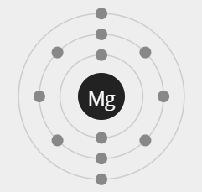Answer the questions below using the Bohr models provided.

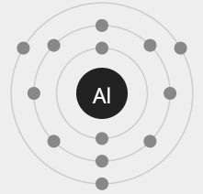Valence electrons: ___________

Will it gain or lose electrons? ________________________

How many? ______________

What will it’s charge be? _____

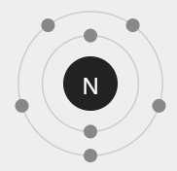Valence electrons: ___________

Will it gain or lose electrons? ___________________________

How many? ______________

What will it’s charge be? ______

Valence electrons: ___________

Will it gain or lose electrons? ________________________

How many? ______________

What will it’s charge be? _____

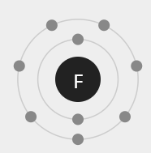

Valence electrons: ___________

Will it gain or lose electrons? ________________________

How many? ______________

What will it’s charge be? _____

Name: ____________________________________________________ Date: __________________ Period: __________

Ion Practice

1. What is the octet rule?
2. ****Answer the questions below using the Bohr models provided.

****Valence electrons: ___________

Will it gain or lose electrons? ________________________

How many? ______________

What will it’s charge be? _____

****Valence electrons: ___________

Will it gain or lose electrons? ___________________________

How many? ______________

What will it’s charge be? ______

Valence electrons: ___________

Will it gain or lose electrons? ________________________

How many? ______________

What will it’s charge be? _____



Valence electrons: ___________

Will it gain or lose electrons? ________________________

How many? ______________

What will it’s charge be? _____

1. Fill out the following table with the information provided. The first row is completed as an example.

|  |  |  |  |  |  |
| --- | --- | --- | --- | --- | --- |
| **Element** | **Protons** | **Electrons** | **Charge** | **Ion Symbol** | **Cation/Anion?** |
| Hydrogen | 1 | 0 | +1 | H+1 | cation |
| Phosphorous |  | 18 |  |  | Anion |
|  | 35 | 36 |  |  |  |
|  |  |  |  | Sr+2 |  |
| Indium |  |  | +3 |  |  |
| Argon |  |  | 0 |  |  |
|  | 3 | 2 |  |  |  |
| Oxygen |  |  |  | O-2 |  |

1. Why do atoms form ions? Explain using the octet rule.
2. Fill out the following table with the information provided. The first row is completed as an example.

|  |  |  |  |  |  |
| --- | --- | --- | --- | --- | --- |
| **Element** | **Protons** | **Electrons** | **Charge** | **Ion Symbol** | **Cation/Anion?** |
| Hydrogen | 1 | 0 | +1 | H+1 | cation |
| Phosphorous |  | 18 |  |  |  |
|  | 35 | 36 |  |  |  |
|  |  |  |  | Sr+2 |  |
| Indium |  |  | +3 |  |  |
| Argon |  |  | 0 |  |  |
|  | 3 | 2 |  |  |  |
| Oxygen |  |  |  | O-2 |  |

1. Why do atoms form ions? Explain using the octet rule.